Object-Oriented Programming Lab
Semester 2
Project Report
“BUS MANAGEMENT SYSTEM”
Group Number: 15

Lab Instructor: Miss. Amna Bibi
Section Name: BSCS-2F
Group Members:
Student ID | Student Name
SU92-BSCSM-F23-193 | Muhammad Talha Hakeem
SU92-BSCSM-F23-508 | Hussain Muhay Ud Din

Department of Computer Science
The Superior University, Lahore (Gold Campus)

Abstract:
The goal of this project is to create and put into place an extensive bus management system that effectively keeps track of bus records and offers consumers a booking system. The Bus Management and Booking Management modules comprise the two primary sections of the system. Administrators can add, amend, and remove bus records, such as the bus number, name, seats, and driver's name, using the Bus Management module. Customers can make seat reservations, check booking details, and cancel reservations using the Booking Management module. Moreover, the system has tools for updating booking details, deleting booking records, and searching for booking data.
The C++ programming language is used to implement the system, which stores and retrieves data via file management. Customers and administrators can engage with the system through an easy-to-use interface. By limiting access to authorized workers and authenticating user input, the system protects the security and integrity of data.
The key features of the system include:
- Bus record management (add, update, delete)
- Booking management (book, view, cancel)
- Search and update booking records
- Delete booking records
- User-friendly interface for administrators and customers
- Data validation and security features
This project aims to enhance the efficiency and reliability of bus management and booking operations, providing a valuable tool for administrators and a convenient booking system for customers. The system’s design prioritizes ease of use, data security, and operational efficiency, making it a comprehensive solution for bus management needs.

Table of Contents
Abstract 2
1. Introduction of the Project 4
2. Modules of the Project 5
3. Classes, Attributes and Methods 6
4. Algorithm used to design the Code 8
5. Concepts used to write the Code 10
6. Output of the Code 13
7. Challenges faced during the Project 20
8. Conclusion 21

Introduction of the Project:
The project is a Bus Management System, a comprehensive software solution designed to manage bus operations, bookings, and customer information. The system provides a user-friendly interface for administrators to manage bus details, bookings, and customer records.
The primary objectives of this project are:
- To design and develop a user-friendly Bus Management System that can efficiently manage bus operations and bookings.
- To provide a secure and reliable system for storing and retrieving customer information.
- To enable administrators to easily update and manage bus details, including routes, schedules, and seat availability.
- To facilitate online booking and payment processing for customers.
The Bus Management System consists of two main modules: Bus Details and Booking Details. The Bus Details module allows administrators to manage bus information, including adding, updating, and deleting bus records. The Booking Details module enables customers to book seats, view booking information, and cancel bookings. The system also provides features for searching and updating booking records, as well as generating reports on bus occupancy and revenue.
The end result of this project is a fully functional Bus Management System that provides a convenient and efficient way to manage bus operations and bookings. The system will enable administrators to streamline their operations, reduce manual errors, and improve customer satisfaction. Additionally, the system will provide valuable insights into bus occupancy and revenue, enabling administrators to make informed decisions to optimize their operations.

Modules of the Project:
Module 1: Bus Management System
- Add Bus Record: Allows the user to add a new bus record, including bus number, bus name, number of seats, and driver's name.
- View Bus Details: Displays all bus records or a specific bus record based on the bus number.
- Update Bus Record: Updates an existing bus record.
- Delete Bus Record: Deletes a bus record.
- Bus Route Details: Displays the route details of a specific bus.
Module 2: Booking Management System
- Book a Seat: Allows the user to book a seat on a specific bus, including selecting the seat number and providing customer information.
- View Booking Details: Displays all booking records or a specific booking record based on the customer's phone number.
- Update Booking: Updates an existing booking record.
- Cancel Booking: Cancels a booking record.
- Show All Bookings: Displays all booking records.
Module 3: Security
Login: Authenticates the user with a username and password.
Module 4: Main Menu
- Choose System: Allows the user to choose between the Bus Management System and the Booking Management System.
These modules cover the basic functions of the project, including bus management, booking management, security, and the main menu.

Tool Used:

The Bus Management System was developed using Visual Studio Code (VS Code), a lightweight, open-source code editor developed by Microsoft. VS Code provides an integrated development environment (IDE) with features such as syntax highlighting, code completion, debugging, and version control, making it an ideal choice for developing C++ applications.

The system was developed on a Windows platform using VS Code version [insert version number]. The C++ compiler used was [insert compiler version, e.g., GCC 9.3.0].

The system consists of two main classes: Bus and Booking System, which are derived from the abstract base class Management System. The code is organized into separate files, with each class having its own header file and implementation file.

The Bus Management System provides a range of features, including bus details management, booking management, and search and update functionality. The system uses file input/output operations to store and retrieve data. The system was thoroughly tested using various test cases to ensure its correctness and reliability. Debugging was performed using VS Code's built-in debugging tools.

Classes, Attributes and Methods
. Classes :
Management System
Bus
Booking System

Attributes :
ManagementSystem Class:
- No attributes defined (pure virtual class).

Bus class:
Private Attributes:
- `string b_no`: Bus number.
- `string b_name`: Bus name.
- `string d_name`: Driver name.
- `int b_seats`: Number of seats.

Booking_System class:
Private Attributes:
- `string b_no`: Bus number (duplicated from Bus).
- `string b_name`: Bus name (duplicated from Bus).
- `string d_name`: Driver name (duplicated from Bus).
- `int b_seats`: Number of seats (duplicated from Bus).

- Methods for Bus class :
- menu()
- new_bus()
-bus_details()
- single_bus()
- all_buses()
- update_bus()
- del_bus()
-bus_route()
- Methods for Booking_system class
Booking_System
- menu()
- booking()
- bus_seatsdetails()
- search_booking()
- update_booking()
- del_booking()
- show_booking()

Algorithm used to design the Code:

1. Display Options: Display the following options to the user:
- `1` to Book Ticket
- `2` to Cancel Ticket
- `3` to Display Booked Tickets
- `4` to Check Seat Availability
- `0` to Exit
2. Receive Option: Receive the user's option. Based on the input:
- If the option is `1`, go to step 3.
- If the option is `2`, go to step 9.
- If the option is `3`, go to step 15.
- If the option is `4`, go to step 19.
- If the option is `0`, go to step 27.
- Else, display `Error! Enter correct choice. ` and go to step 1.
3. Book Ticket:
- Prompt for Bus Number.
4. Receive and Save Bus Number: Receive and save the bus number.
5. Prompt for Passenger Name: Ask the user to enter the passenger's name.
6. Receive and Save Passenger Name: Receive and save the passenger's name.
7. Prompt for Seat Number: Ask the user to enter the seat number.
8. Receive and Save Seat Number: Receive and save the seat number.
- Check if the seat is already booked:
- If the seat is available, book the seat and display `Ticket Booked Successfully! `.
- Else, display `Error! Seat already booked.`.
9. Cancel Ticket:
- Prompt for Bus Number.
10. Receive and Save Bus Number: Receive and save the bus number.
11. Prompt for Seat Number: Ask the user to enter the seat number.
12. Receive and Save Seat Number: Receive and save the seat number.
- Check if the seat is already booked:
- If the seat is booked, cancel the ticket and display `Ticket Cancelled Successfully! `.
- Else, display `Error! Seat not booked.`.
13. Display Booked Tickets:
- For each bus, display the bus number and the list of booked tickets.
14. Check Seat Availability:
- Prompt for Bus Number.
15. Receive and Save Bus Number: Receive and save the bus number.
16. Display Seat Availability:
- Display the list of available seats for the specified bus.
17. Exit: Display `Exiting the system...`.

.

Concepts used to write the Code:
1. Inheritance: The code uses inheritance to create a hierarchy of classes. The Bus and Booking System classes inherit from the Management System class, which is an abstract base class. This allows the derived classes to inherit the common attributes and methods of the base class.
Relevant code:
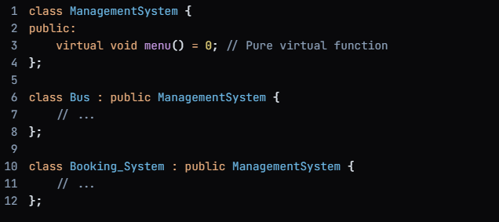
- Polymorphism: The code uses polymorphism to achieve runtime binding of methods. The menu () method is declared as a pure virtual function in the Management System class, and it is overridden in the derived classes Bus and Booking System. This allows the correct implementation of the menu () method to be called based on the type of object.
Relevant code:
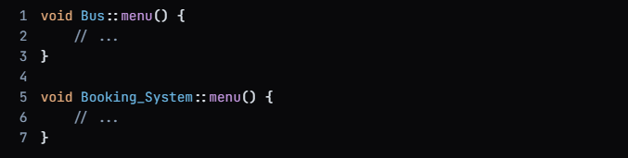
- Data Abstraction: The code uses data abstraction to hide the implementation details of the classes from the outside world. The classes encapsulate their data members and provide public methods to interact with them.
Relevant code:
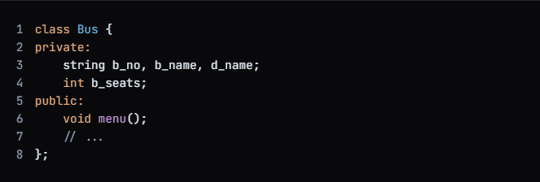
- Loops (While/For): The code uses loops to iterate over data and perform repetitive tasks. For example, the while loop is used to read data from a file and the for loop is used to iterate over an array.
Relevant code:
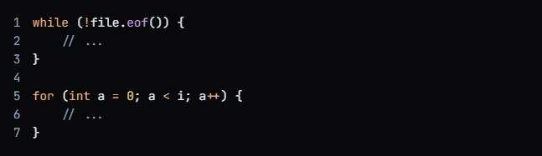
- Conditional Statements(If-else): The code uses conditional statements to make decisions based on certain conditions. For example, the if-else statement is used to check if a file is open or not.
Relevant code:
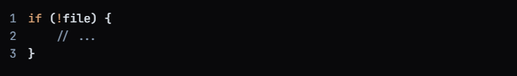
- Arrays: The code uses arrays to store data in a structured way. For example, the ss_no array is used to store the seat numbers of a bus.
Relevant code:
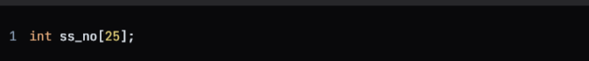
- File Handling: The code uses file handling to read and write data to files. For example, the bus.txt file is used to store the details of the buses.
Relevant code:
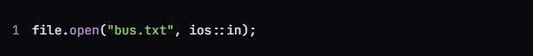
- Database: The code does not use any database APIs.
- APIs: The code does not use any external APIs.

Output of the Code:
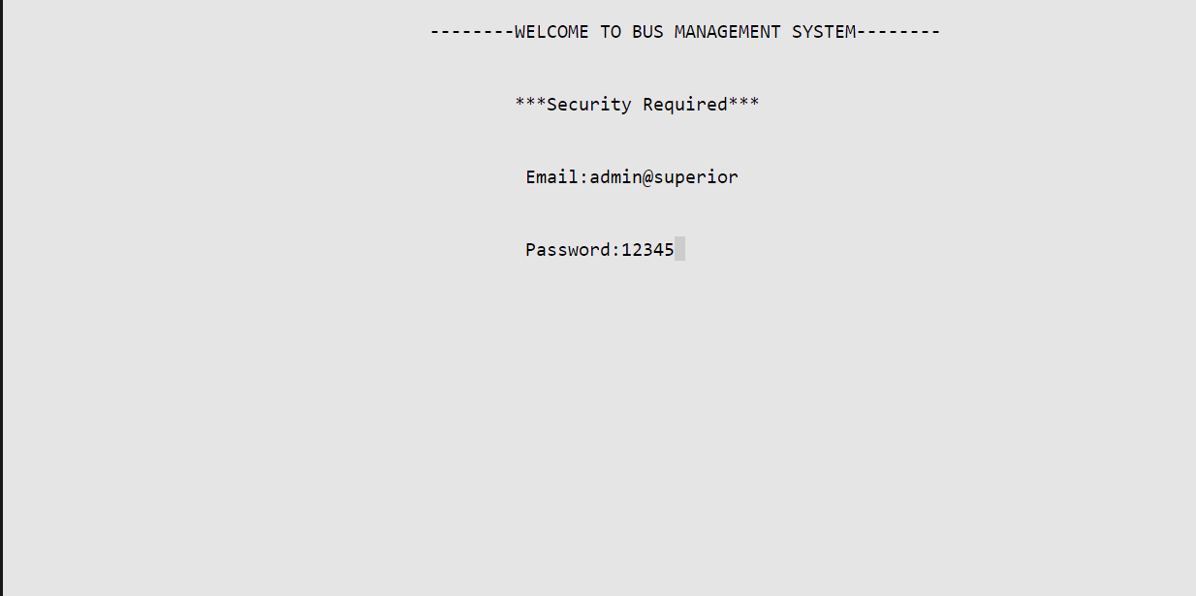
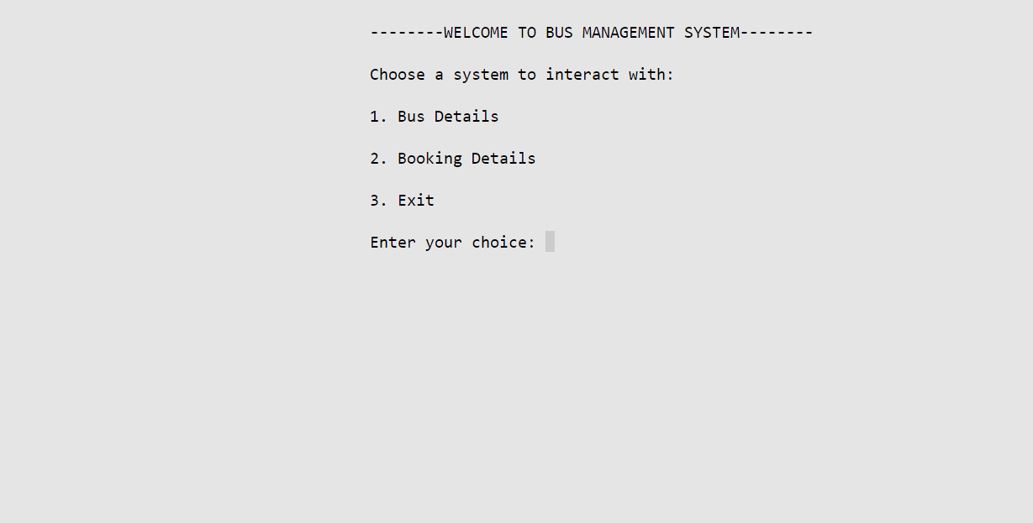
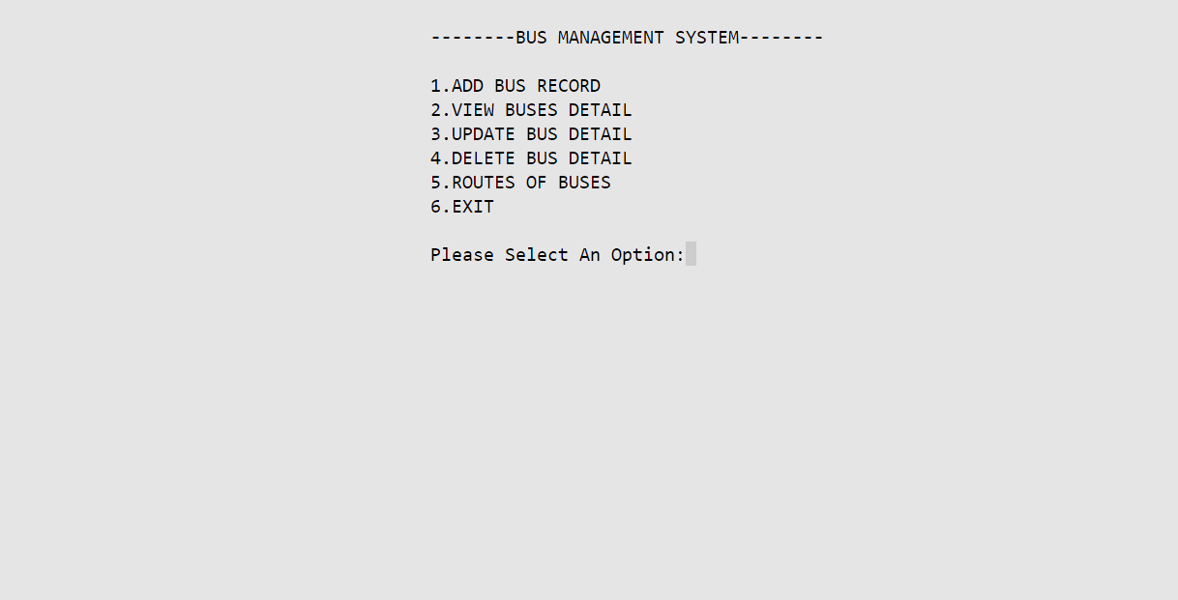
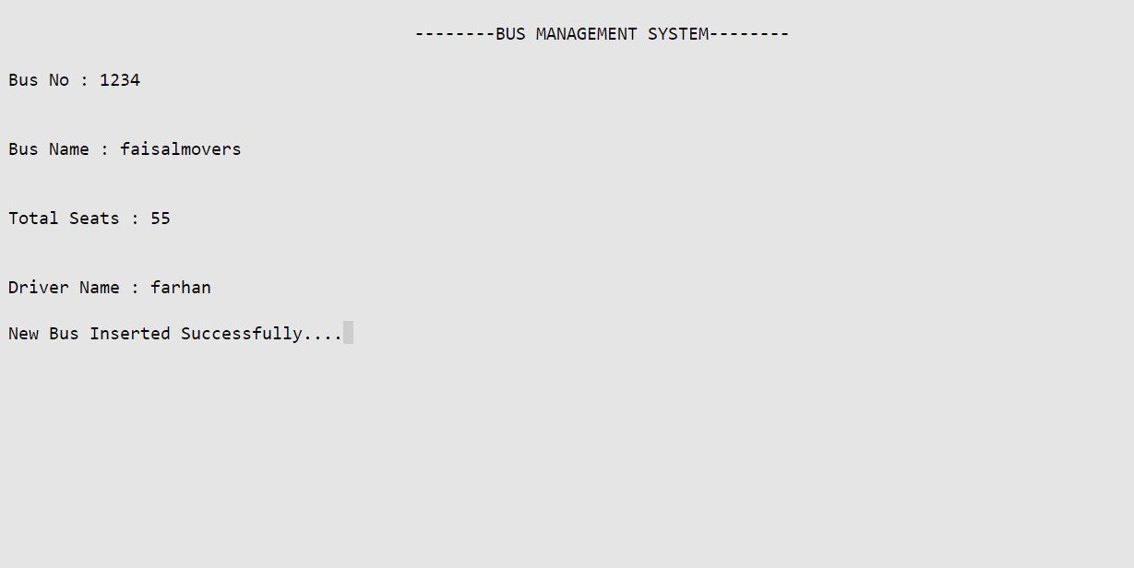
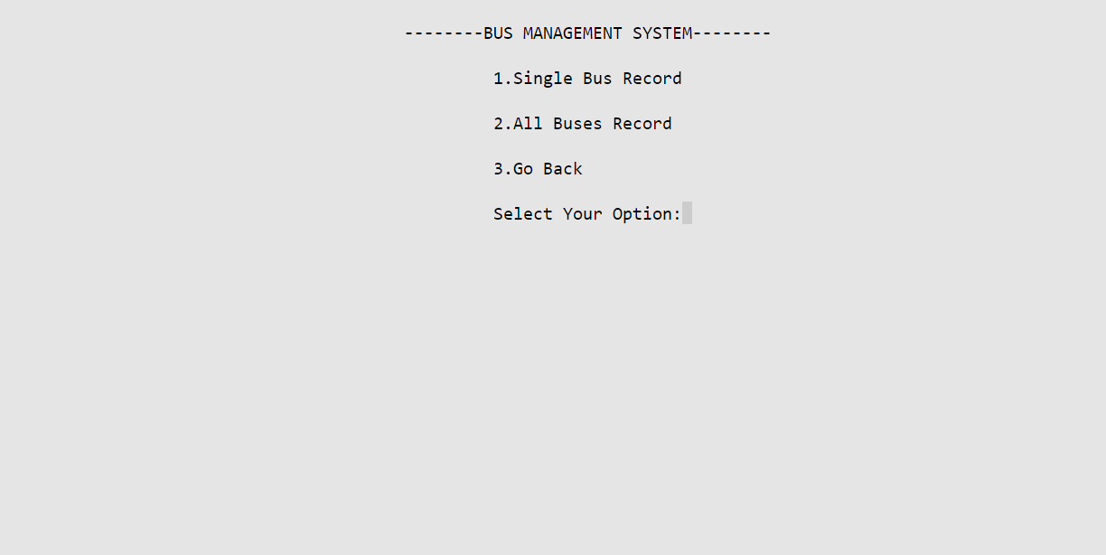
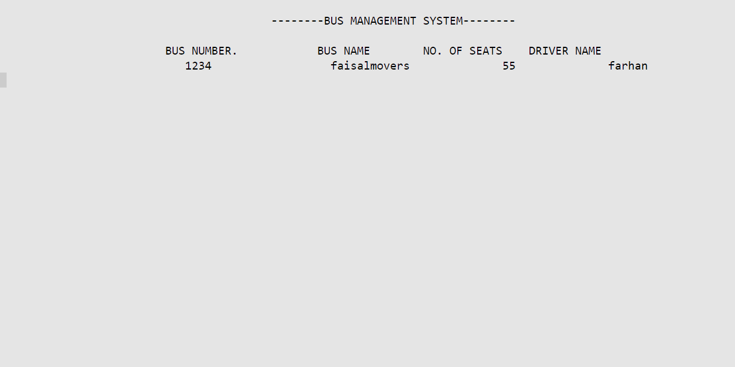
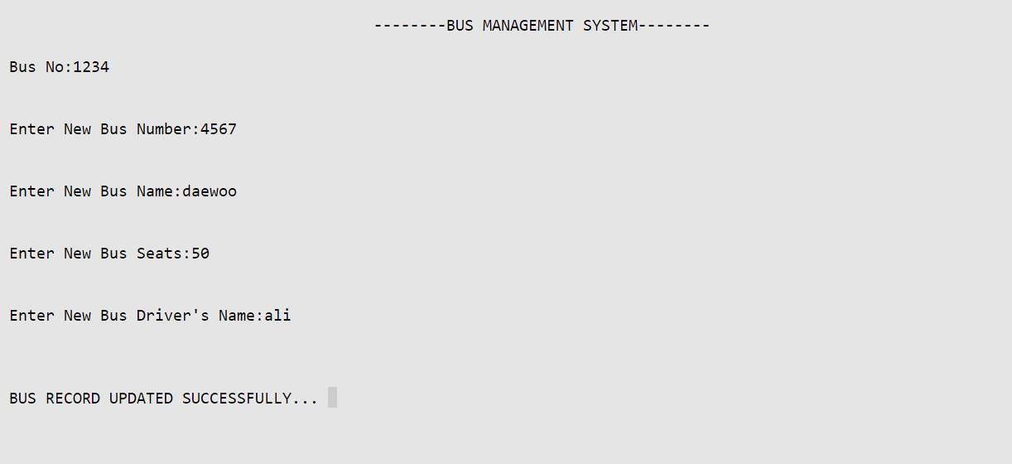
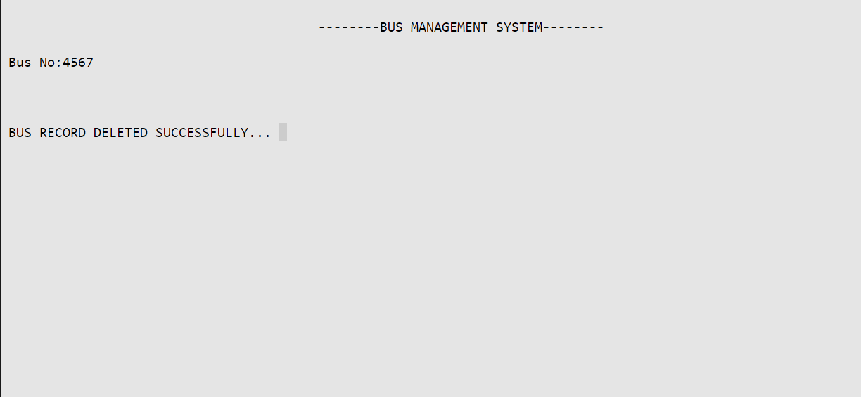
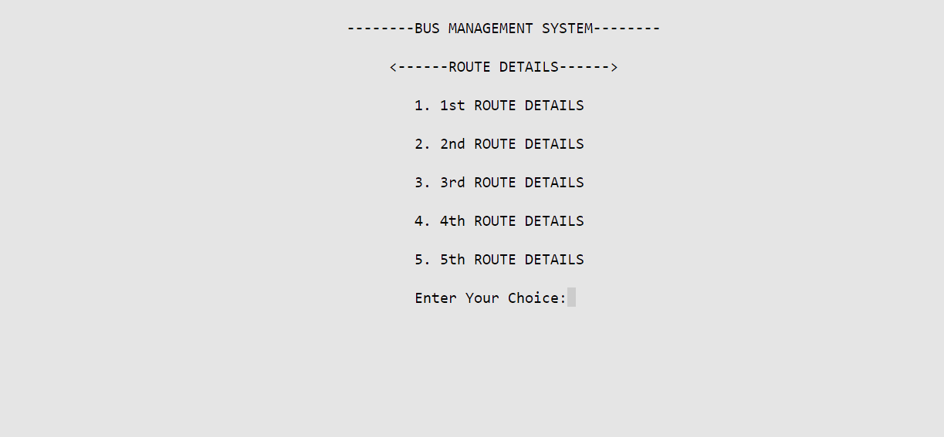
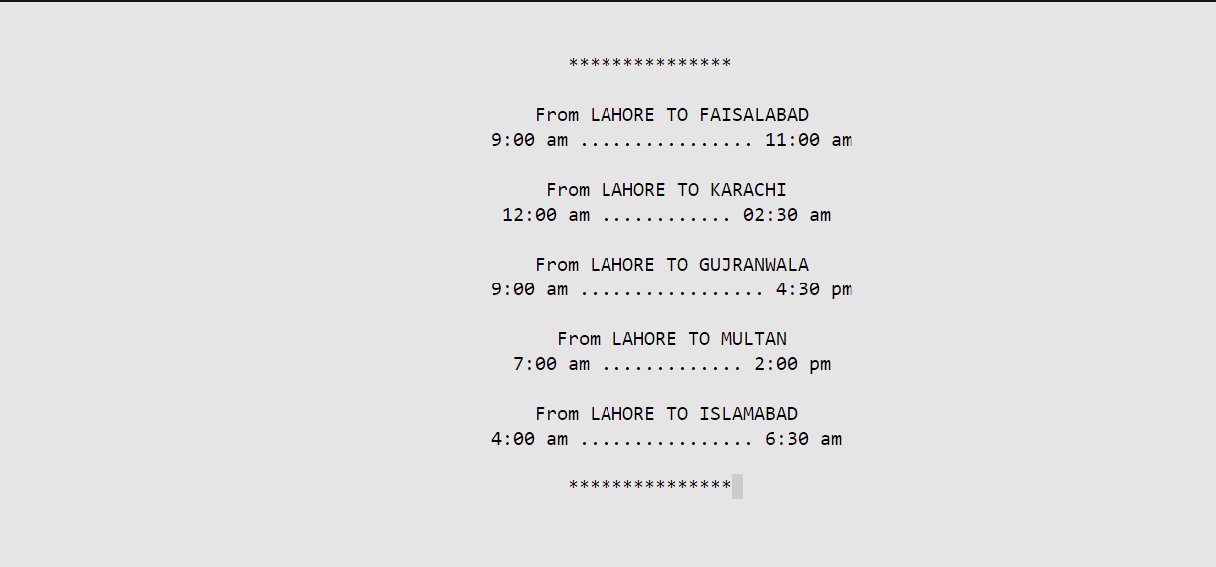
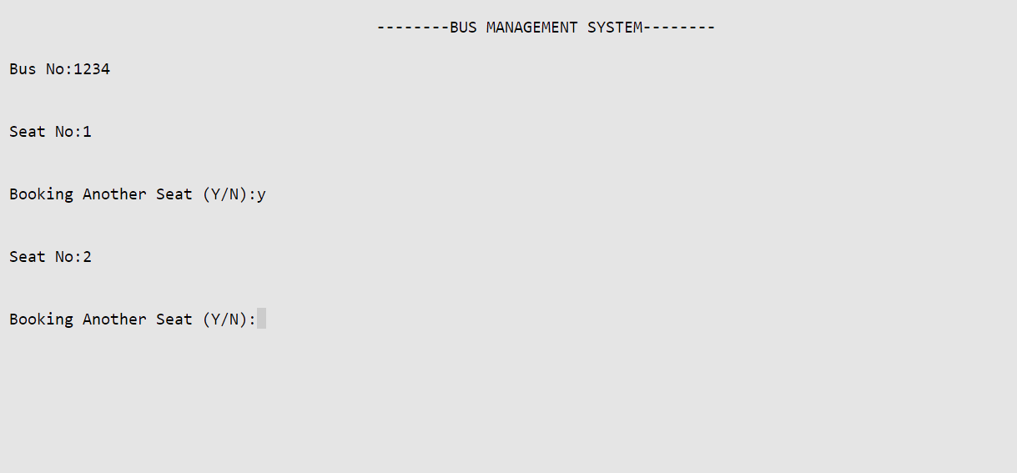
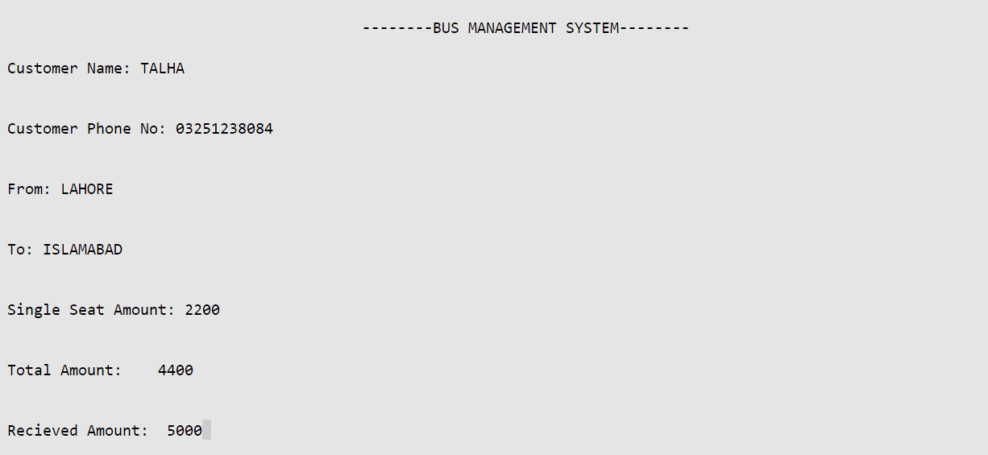
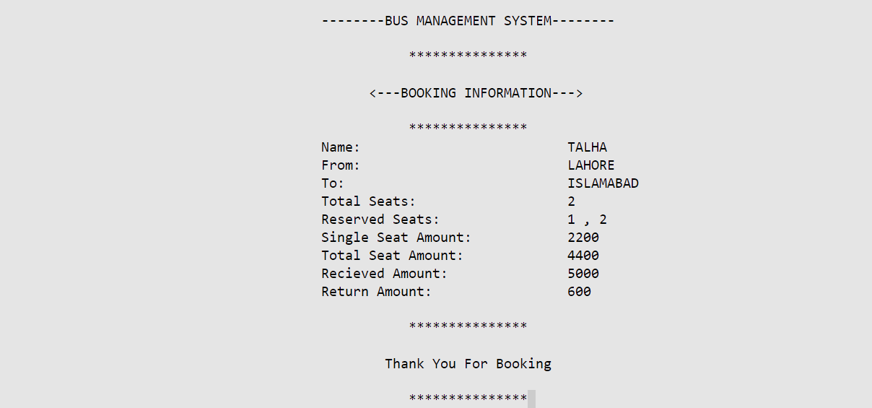
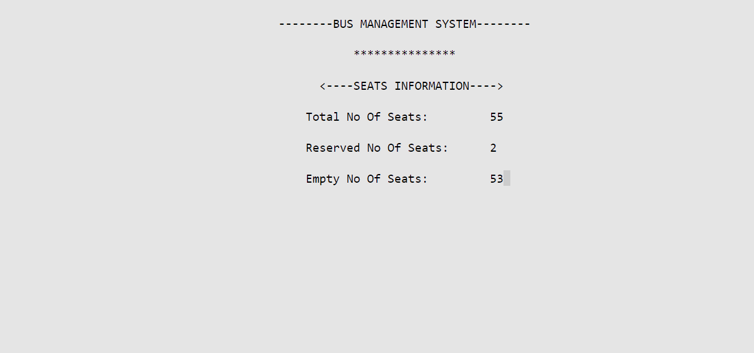
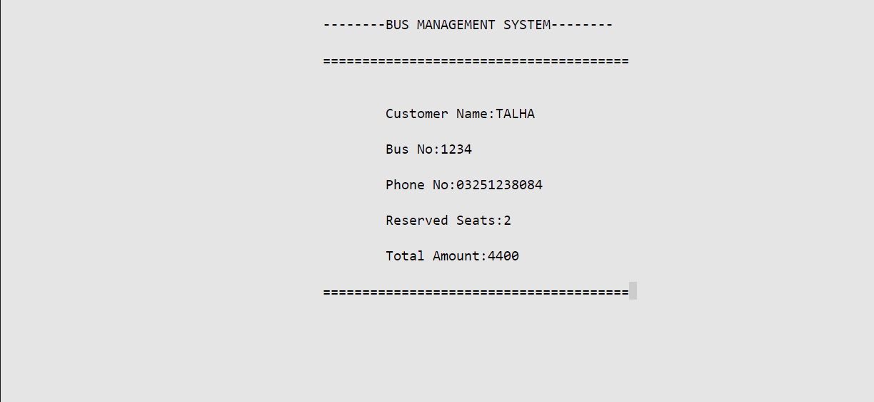
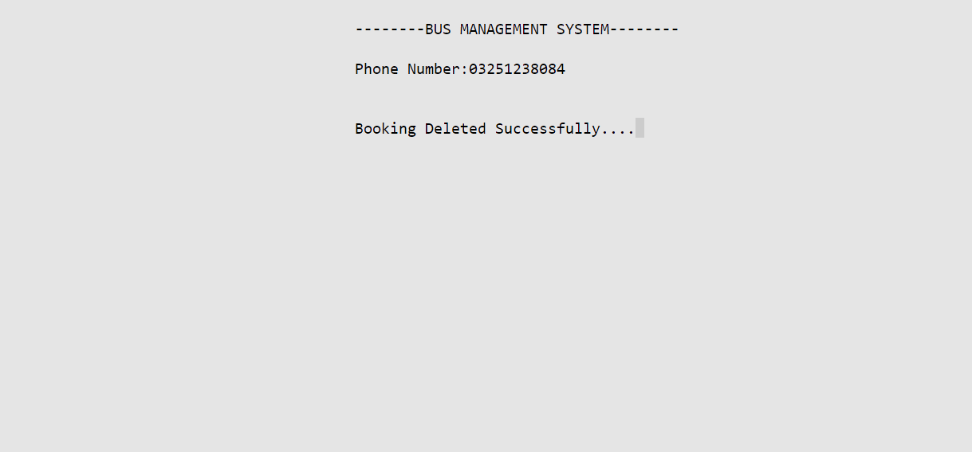

Challenges faced during the Project:
In my project, I initially faced some limitations with Dev C++. It lacked some modern features and extensions that I needed for efficient development and debugging. This led me to switch to Visual Studio Code, which provided better support for C++ development, including a richer set of extensions, integrated terminal, and easier configuration management.
Implementing file handling in C++ can be tricky, especially when dealing with large volumes of data or complex file structures. I encountered issues with file reading and writing, such as incorrect data parsing or handling of end-of-file conditions. Overcoming these required careful debugging and ensuring robust error handling mechanisms. Sometimes, initial project requirements may not fully capture all the necessary functionalities or edge cases. This can lead to scope creep or misunderstandings during implementation. To address this, I had to frequently communicate with stakeholders to clarify requirements and adjust the project scope accordingly.
Ensuring the reliability and stability of the application through comprehensive testing and debugging is crucial. I faced challenges in setting up automated testing frameworks and debugging complex logical errors. Adopting test-driven development practices and utilizing debugging tools helped in identifying and fixing issues efficiently.
Each of these challenges provided valuable learning experiences and improved my problem-solving skills throughout the project. Adaptability, persistence, and effective communication were key in overcoming these challenges and successfully delivering a robust software solution.

Conclusion:
In conclusion, this project aimed to design and develop a comprehensive Bus Management System that integrates two primary modules: Bus Details and Booking Details. The system allows users to manage bus records, including adding, updating, and deleting bus information. Additionally, it enables customers to book seats, view booking details, and cancel bookings. The system also provides features for administrators to manage bookings, view customer information, and update bus schedules.
Through this project, we successfully implemented a user-friendly and efficient Bus Management System using C++ programming language. The system's functionality was tested and validated, ensuring that it meets the requirements of a real-world bus management system.
The key features of the system include bus record management, booking management, and customer information management. The system's user interface is intuitive, making it easy for users to navigate and perform various tasks.
This project demonstrates the importance of effective management systems in the transportation industry. By automating bus management tasks, the system can help reduce errors, increase efficiency, and improve customer satisfaction.
Overall, this project showcases the potential of technology in improving the operations of bus management systems, and its successful implementation can have a significant impact on the industry.

